**OOJ LAB**

**Question 1:**

#include<stdio.h>

int main()

{

int c,a,b,i;

while(1)

{

printf("PRESS THE NUMBER TO CHOOSE THE OPERATION :\n");

printf("1) Add\n");

printf("2)Subtract\n");

printf("3)Multiply\n");

printf("4)Divide\n");

printf("5)Modulus\n");

printf("6)Greater than\n");

printf("7)Lesser than\n");

printf("8)Equal to\n");

printf("9)Not equal to\n");

printf("10)Increement\n");

scanf("%d",&i);

printf("Enter two numbers to perform the selected operation:\n");

scanf("%d%d",&a,&b);

switch(i)

{

case 1:printf("%d + %d = %d \n",a,b,a+b);break;

case 2:printf("%d - %d = %d \n",a,b,a-b);break;

case 3:printf("%d x %d = %d \n",a,b,a*b);break;

case 4:printf("%d / %d = %d \n",a,b,a/b);break;

case 5:printf("%d mod %d = %d \n",a,b,a%b);break;

case 6:if(a>b)

{

printf("%d > %d \n",a,b);

}

else

{

printf("%d > %d \n",b,a);

}

break;

case 7:if(a<b)

{

printf("%d < %d \n",a,b);

}

else

{

printf("%d < %d \n",b,a);

}

break;

case 8:if(a==b)

{

printf("%d = %d \n",a,b);

}

else

{

printf("%d != %d \n",b,a);

}

break;

case 9:if(a!=b)

{

printf("%d != %d \n",a,b);

}

else

{

printf("%d = %d \n",b,a);

}

break;

case 10:

printf("%d++ = %d \n",a,a+1);

printf("%d++ =%d \n",b,b+1);

break;

default:printf("WRONG INPUT!\n");

}

printf("Press 1 to perform calculation again\nPress any other key to exit\n");

scanf("%d",&c);

if(c!=1)

{

break;

}

}

}

**Output:**

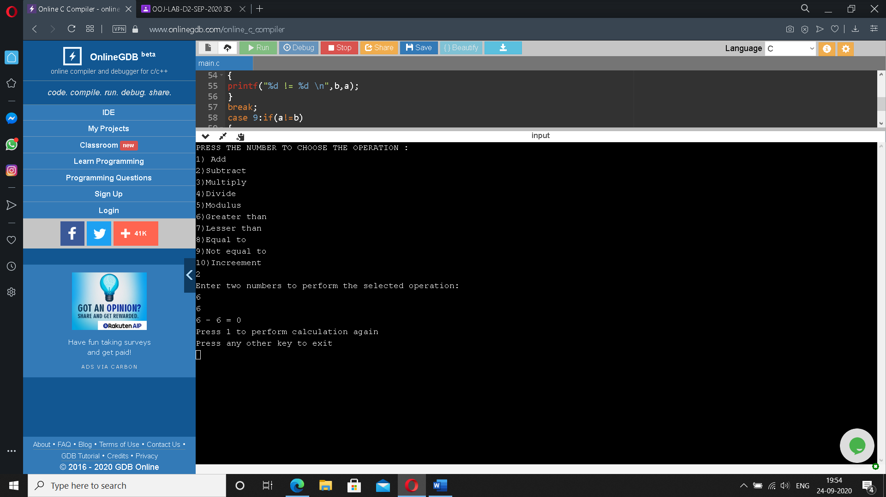

**Question 2:**

#include <stdio.h>

int sumaver(int a,int b)

{

int sum;

sum=a+b;

printf("Sum= %d \n",sum);

return sum/2;

}

void printeven(int a,int b)

{

int small,big;

if(a>b)

{

small=b;

big=a;

}

else

{

small=a;

big=b;

}

printf("Even numbers between two numbers are:\n");

int i;

for(i=small+1;i<big;i++)

{

if(i%2==0)

printf("%d \n",i);

}

}

int main()

{

int a,b,c,avg,g1,g2;

printf("Enter three numbers:\n");

scanf("%d%d%d",&a,&b,&c);

if(c<a && c<b)

{

g1=a;

g2=b;

}

else if(b<a && b<c)

{

g1=a;

g2=c;

}

else

{

g1=b;

g2=c;

}

avg=sumaver(g1,g2);

printf("Average of two numbers is : %d \n",avg);

printeven(g1,g2);

}

**Output:**

